**Bo Lin**

**ECE 479/579 Digital Control Systems**

Homework Assignment #1

1. Most control systems require some type of motive power. One of the most commonly used units is the electric motor. Write the differential equation for the angular displacement of a moment of inertia, with damping, connected directly to a dc motor shaft when a voltage is applied to the armature terminals with the field separately energized.

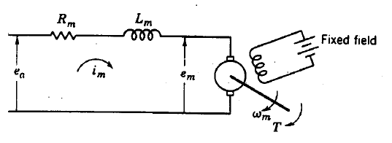

First list the four basic equations according to Kirchhoff Circuit Laws and Electromechanical principles,



Replace  in (1) with (4)



Replace  in (3) with (2), replace  with (5)



Because



Replace with (7)



Transfer (8) to S domain using Laplace transfer



The finally transfer function is

